**MyTomorrow App**

**Cincinnati Public Schools**

**Website Manual**

**Version 3.0**

**Table of Contents**

1 Student & Teacher Website 3

1.1 Logging in 3

1.2 Student Login 6

1.3 Teacher Login 33

1.4 Logging Out: 49

# Student & Teacher Website

## Logging in

To log in to the Cincinnati Public Schools website as a Student or Teacher, perform the following steps:

* Click the **Student** or **Teacher** button from the log in screen.

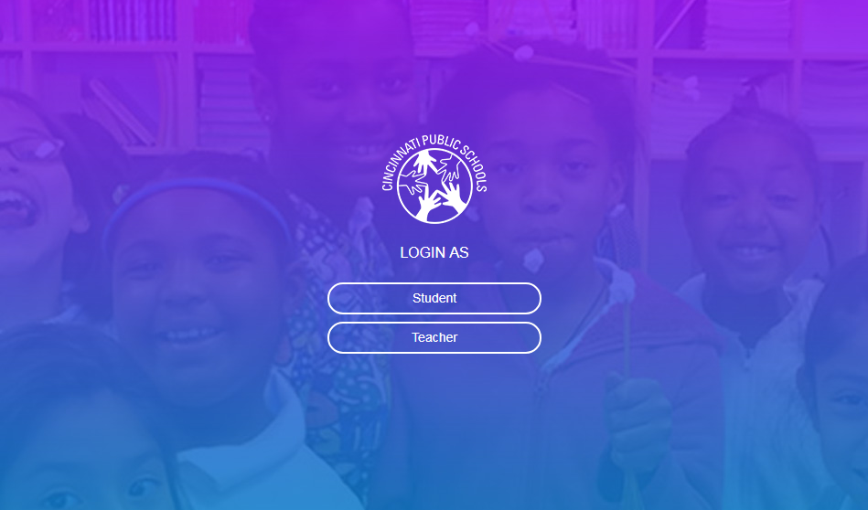

* After selecting the appropriate button, you will be redirected to the Sign in with Google screen.
* Click the **Sign in with Google** button, you will be redirected to the Choose an Account screen.



* On this screen, select an existing account or create a new account. Provide the password when prompted.

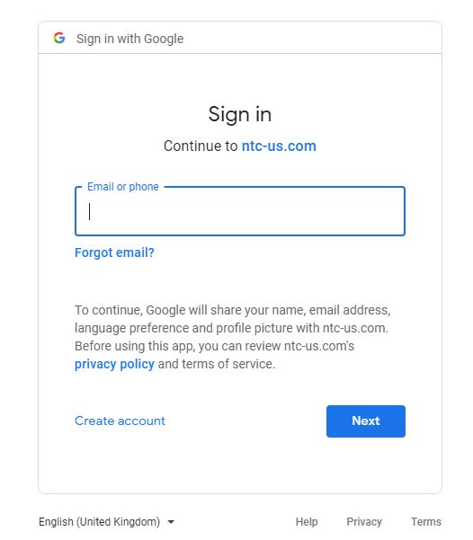

* After entering a valid password, you will be redirected to the dashboard screen of the CPS website.

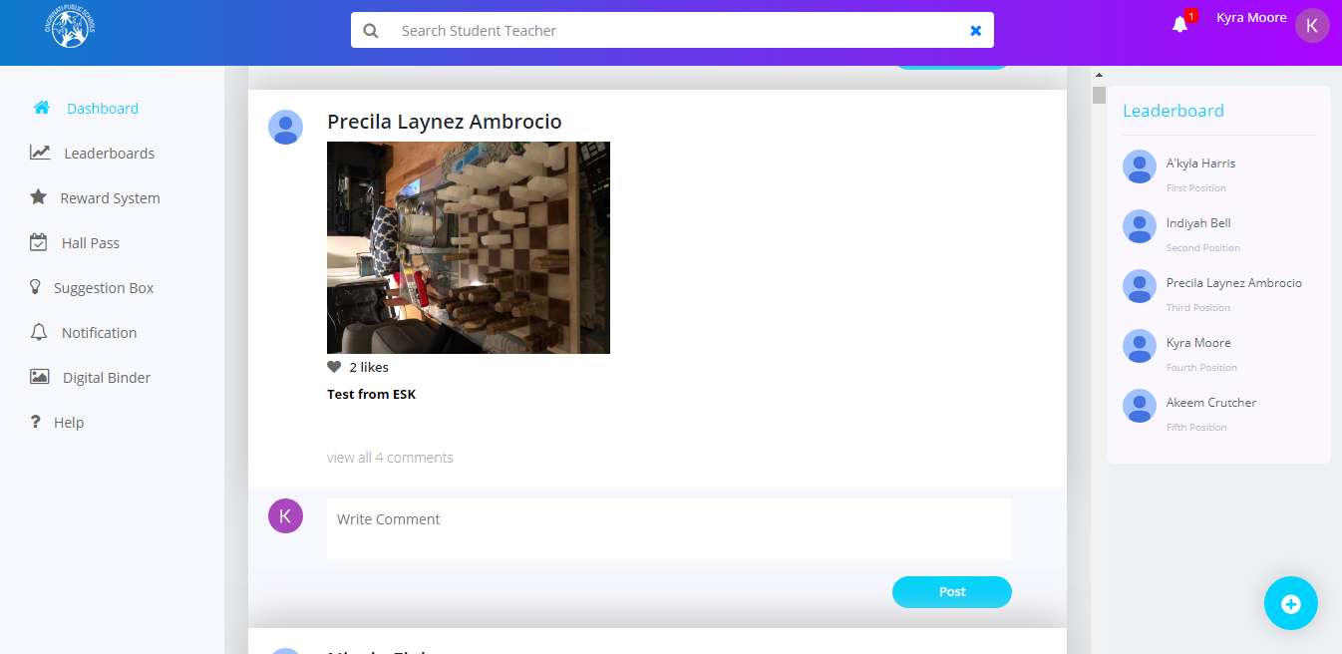

## Student Login

### Dashboard:

When you log in as a student, you can view the Newsfeeds (posts) posted by the students, teachers or admin users on the Dashboard screen.

#### Search:

Students can search for information on the website based on certain key words. There is a **Search** text box available at the top of the Dashboard screen. They can type in their keyword and the search result will be displayed below the **Search** text box based on the keyword typed in.

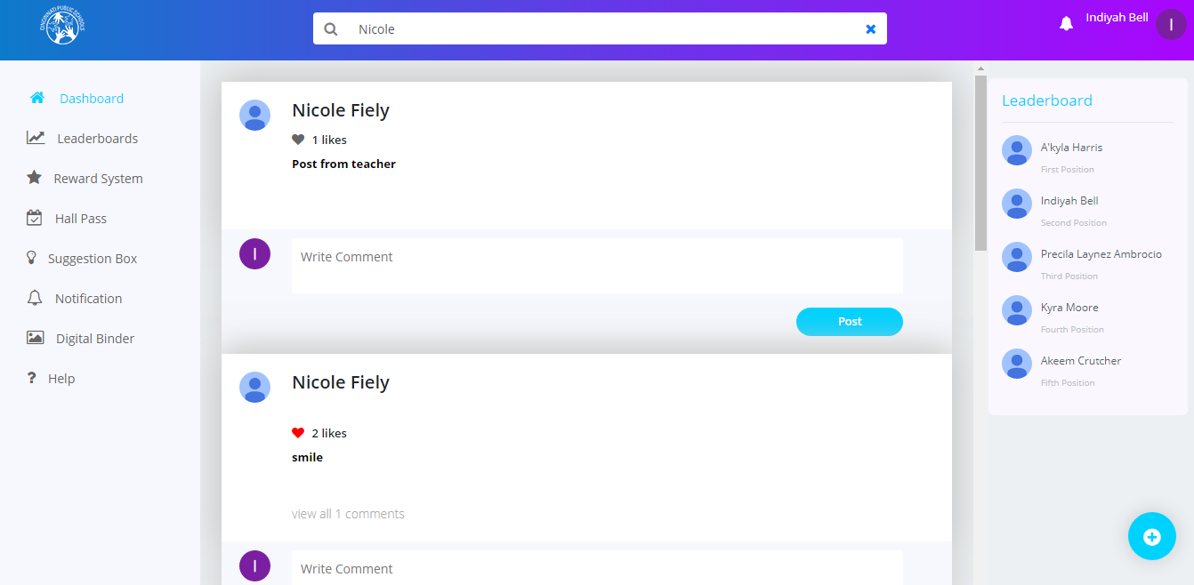

#### Adding a Newsfeed

On this screen, students can post content including text, oictures, videos They can also like and comment on various posts .

To add a news feed:

* Click the + icon. The Create News window is displayed.

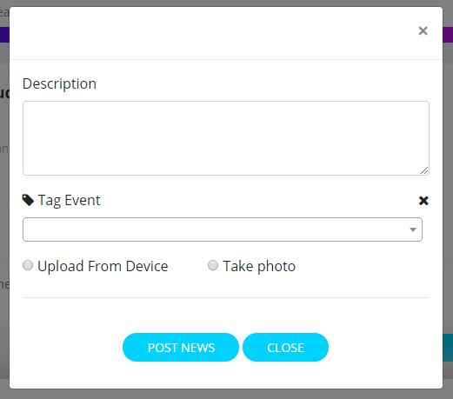

* In this screen, you can upload a file from the device or you can take a picture using the webcam.
* A user also can tag the event by selecting tag event dropdown.
* After filling in the information, click on the **Post News** button to post the news feed.

**Note:** There are certain rules and regulations for a student while posting a new newsfeed (post) or when commenting on an existing newsfeed. A student cannot post any objectionable content, pictures or videos . All the posts made by Students need to be approved by an approver before being posted on the website. The approver can approve or reject a students’ newsfeeds.

Editing or Deleting a News Feed

Students can edit or delete only their newsfeeds posted on their individual dashboards by clicking the icon above.

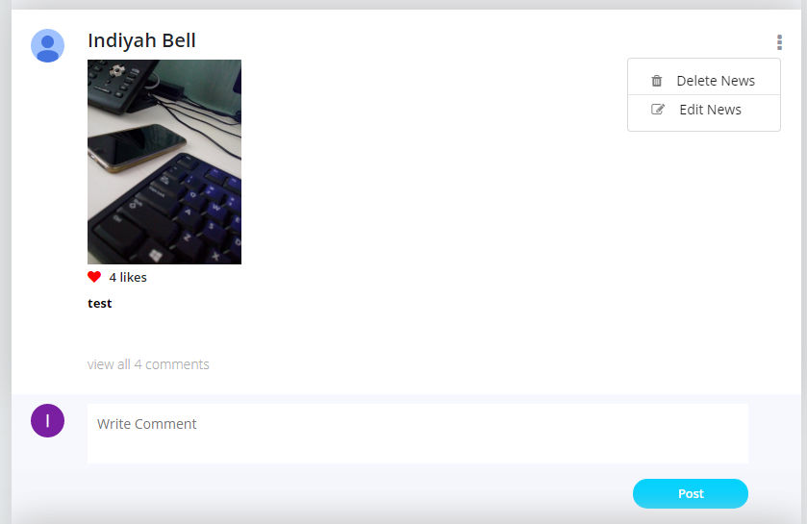

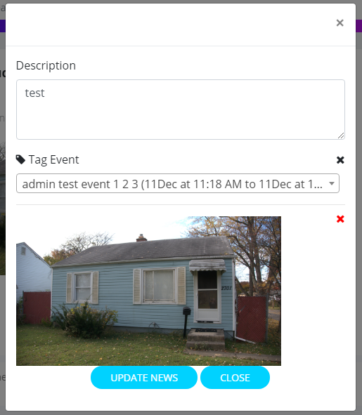

#### To edit a newsfeed:

* Click on the icon and click the **Edit News** button. The Edit News feed window will be displayed.
* Edit the description and upload a different image or
* Click the **Update News** button to save your changes
* To remove image/video/ event from the news feed post use need to click the “X” icon and click on close button

**Note:** You need to delete the existing video or image to upload a new one in its place.

To delete a newsfeed:

* Click on the icon and click the **Delete News** button.

### Adding Event to personal calendar:

* Click in the  icon to add the event to calendar

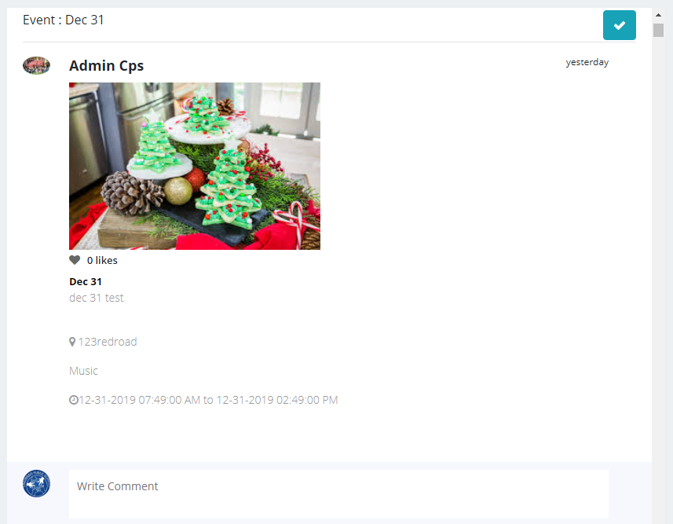

### Commenting on a Newsfeed

Students can comment on newsfeeds in displayed in the Dashboard screen.

To comment on a newsfeed:

* Select the newsfeed you wish to comment on from the Dashboard screen.
* Type your comment in the **Write** text box.
* Click the **Post** button.

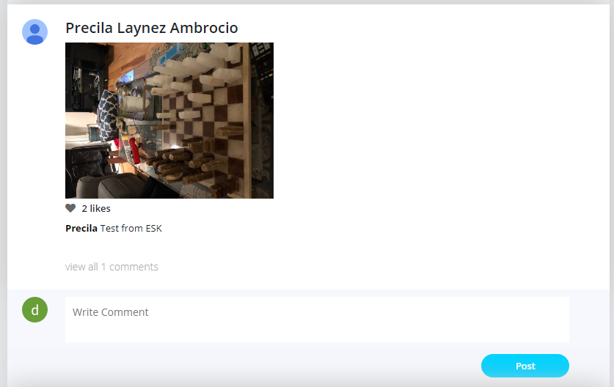

**Note:**

* All the comments made by Students need Admin approval.
* You can view all the comments for that news feed by clicking the view all comments link.

### Notifications

On this screen, the students can view all the notifications sent to them.

To view your notifications:

* Click the Notifications bell icon to view all the top notifications.
* Click on a notification to view its details.

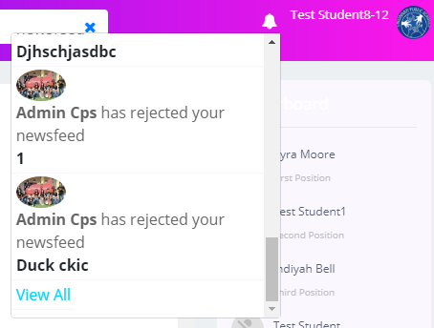

**Note:** To view all the notifications including the likes or comments made on your posts, notifications sent when the hall pass is approved, you can click the View All link at the bottom of the notifications list or click the Notification link in the Dashboard screen.

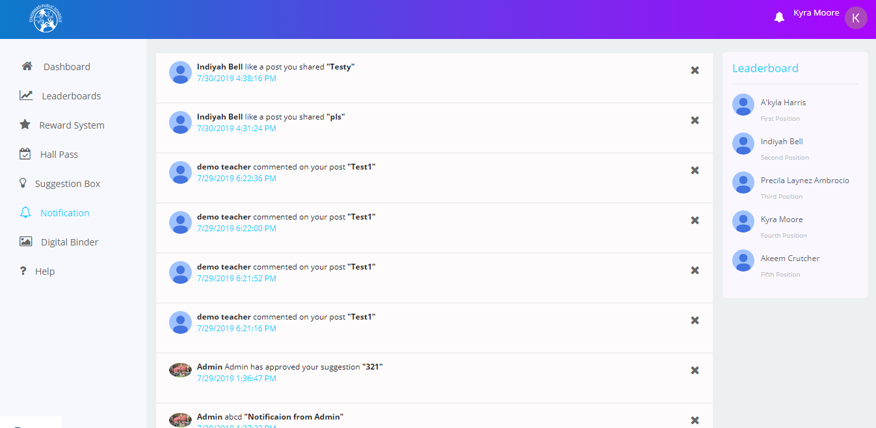

### Leaderboards:

The Leaderboards screen displays the details of the logged in Student. Details including rank, points, levels. are displayed. This screen also displays the number of points required to reach the next levels. You can filter these details by selecting or unselecting the **My School** checkbox.

**Note:** If the **My School** checkbox is selected after logging in, then you can view only the details of the students who belong to your own school and if the checkbox is unselected, you can view the details of all the students of all the schools.

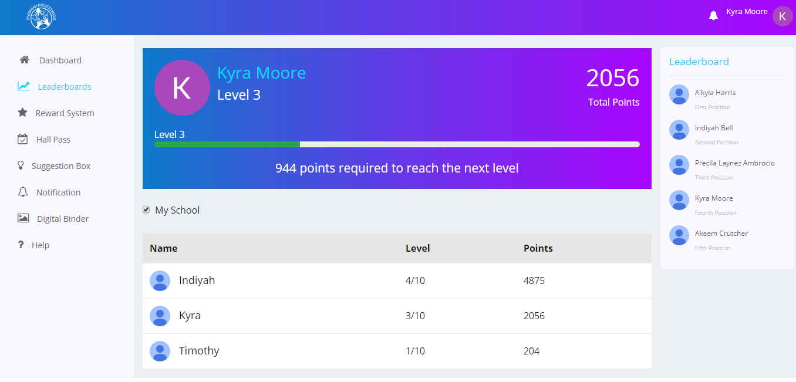

### Rewards System:

The Rewards System screen displays the details of the logged in student including total points, rank. This screen contains two buttons **Redeem my Points** and **How to Earn Points**. You can click the **Redeem my Points** button to redeemyour reward points. You can click the **How to Earn Points** button to get help on how to earn points.

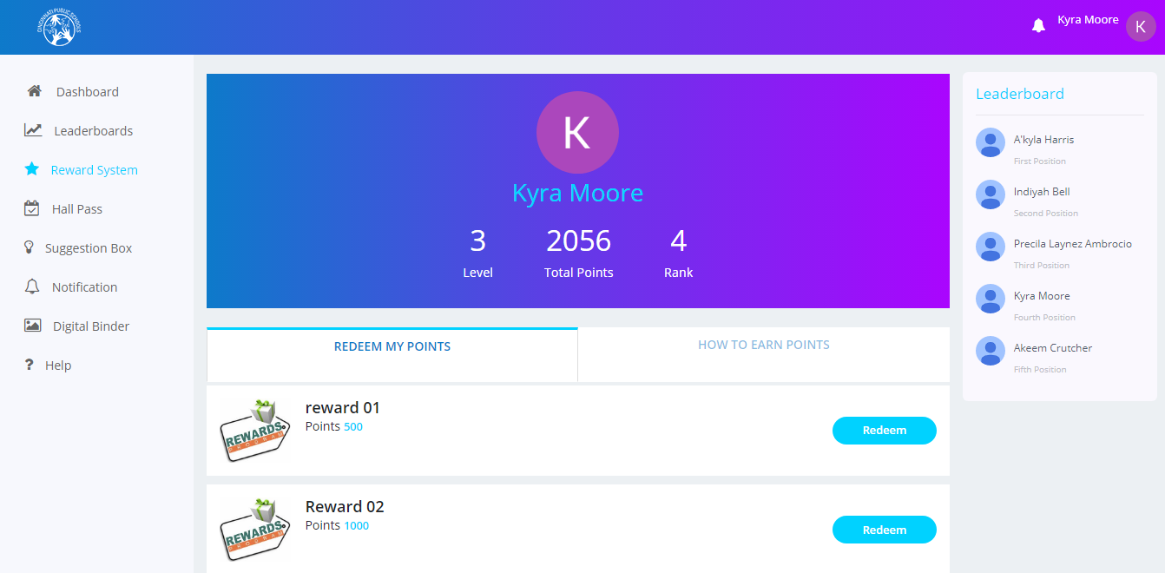

### Hall Passes:

The Hall Passes screen consists of two tabs- **Request a hall pass** tab which displays all the hall pass requests along with the status of the respective hall pass and the **My Passes** tab which displays all the hall passes requested by the logged in user along with details including name, valid from(Validity), expires on (Expiry), description, destination, approved by.

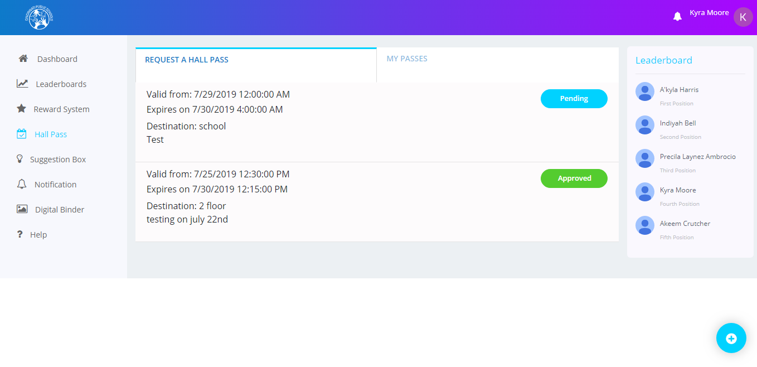

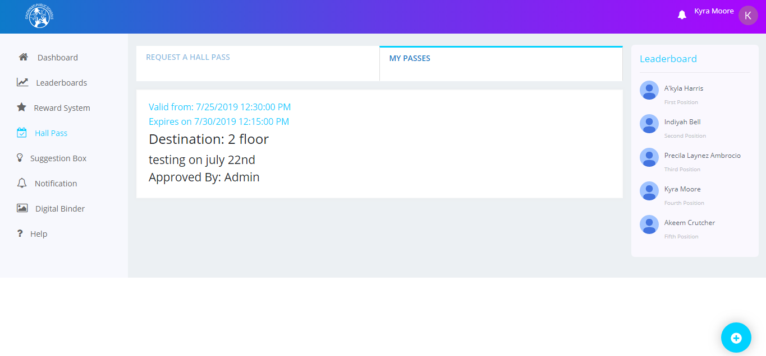

#### Adding a new Hall Pass

To add a new hall pass:

* Click the + icon displayed at the bottom right corner of the Request a hall pass screen.
* The New Hall pass window is displayed.
* On this screen, fill in information such as requesting teacher’s name, reason, destination, Ssart date time, end date time

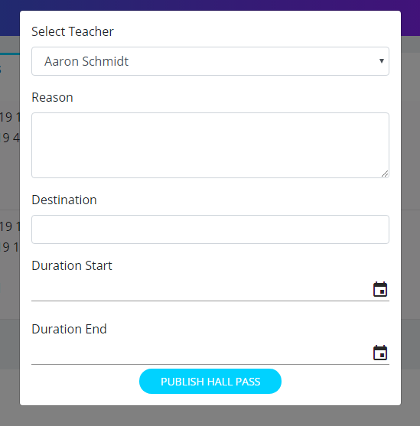

* Click the **Publish Hall Pass for Student** button at the bottom of the screen. After clicking this button, a hall pass request will be generated, and the selected teacher and the administrator will get a notification asking for the approval or rejection of that hall pass.

### Suggestion Box :

The Suggestion Box screen for students has three tabs - **Suggestion Feed**, **My Suggestions**, and **Suggestion**. The **Suggestion Feed** tab displays the suggestions of all the students logged in to the app. You can like or comment on those suggestions.

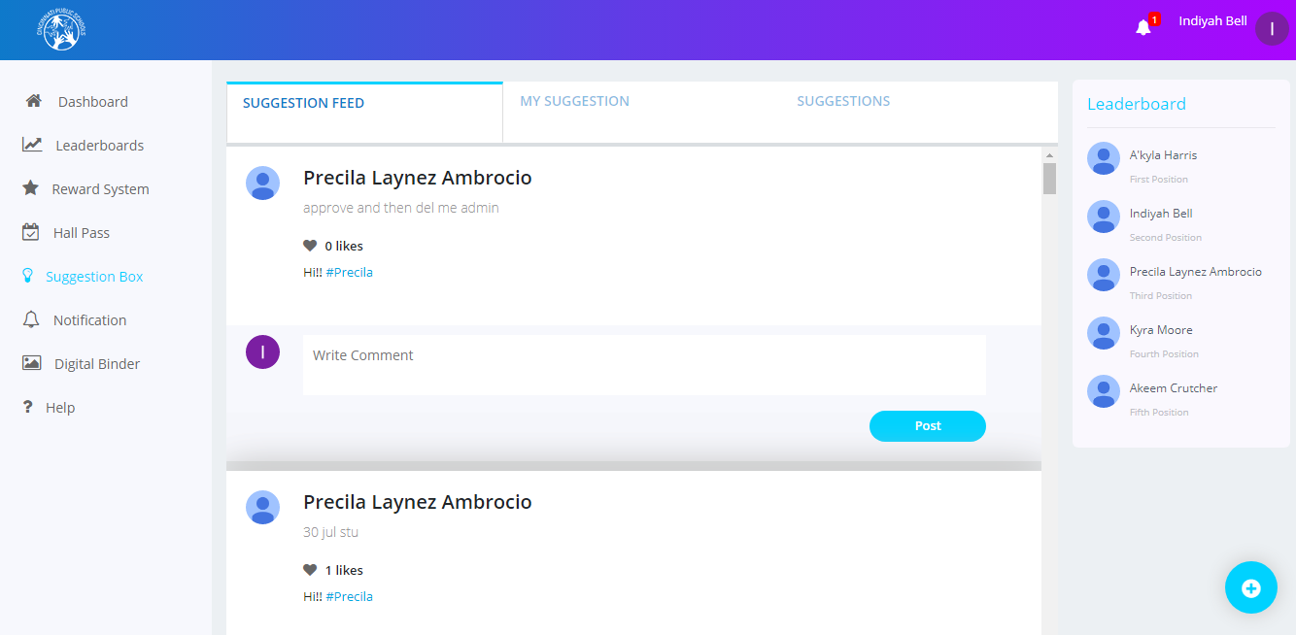

#### Adding a New Suggestion

To add a new suggestion:

* You can add a new suggestion by clicking the + icon displayed at the bottom of the **Suggestion Feed** tab.
* The Create Suggestion window is displayed.

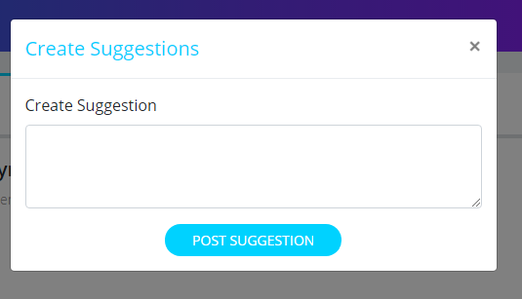

* Describe your suggestion in the Create Suggestion text box and click the **Post** **Suggestion** button to post your suggestion.

The **My Suggestions** tab displays the suggestions posted by you -the logged in user. It also displays the likes and comments on the respective suggestion selected by you.

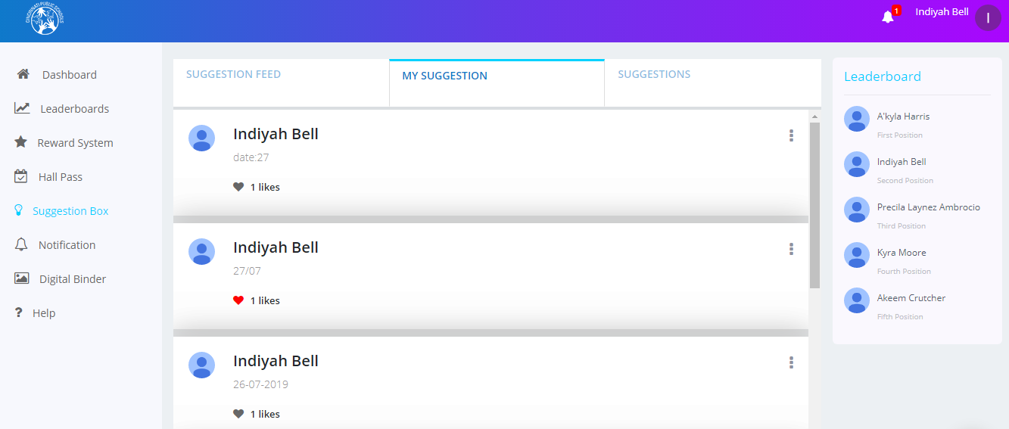

The **Suggestion** tab contains a student’s suggestions along with the status of the suggestions such as approved, pending or rejected.

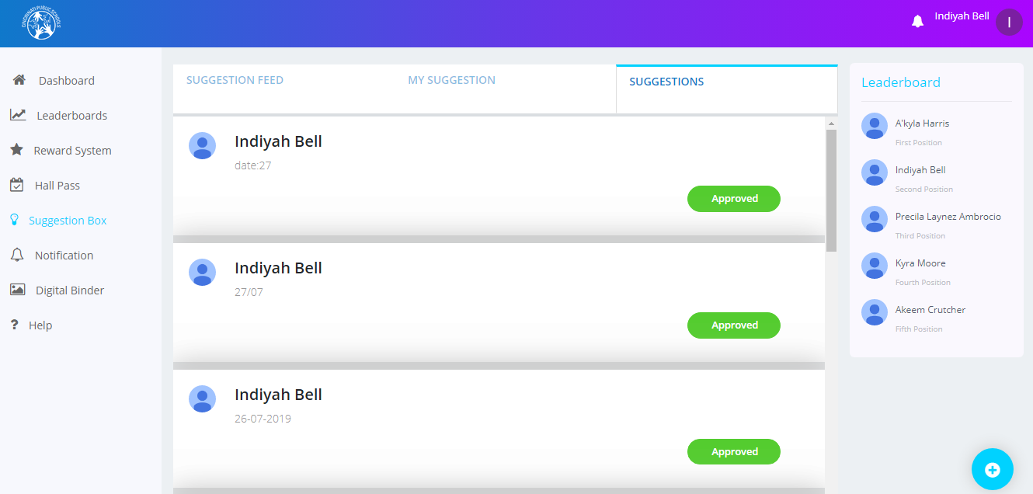

### Digital Binder:

The Digital Binder screen displays all the assignments of a student. A student can add a new assignment from this screen.

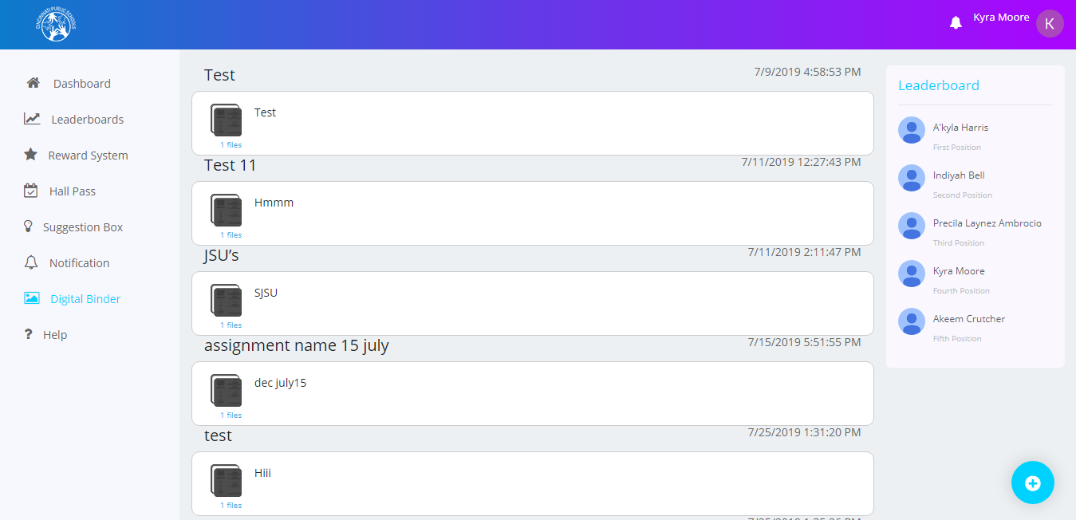

#### Adding a New Assignment

To add a new assignment:

* Click the + icon displayed at the bottom of the Digital Binder screen. The **New Assignment** window is displayed.

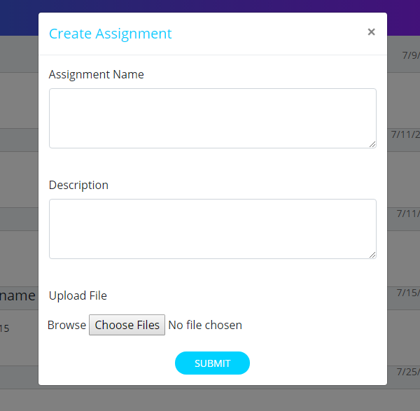

* Specify the assignment name and description, attach media such as pictures or videos and click the **Submit** button.

You can also edit the assignments and view their attachments.

To edit assignments:

* Click the file icon on the Digital Binder screen. The Edit Assignment window will be displayed.

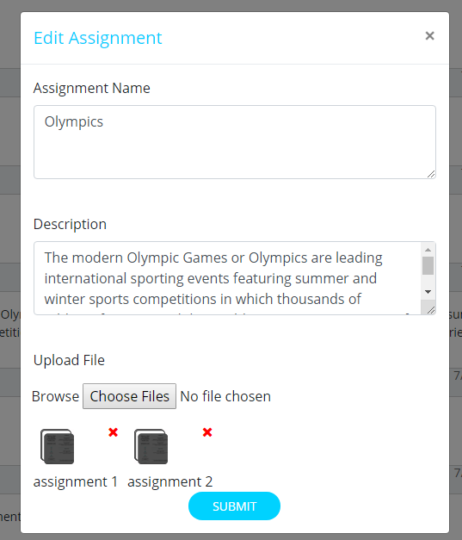

You can edit the details of the assignment and view or remove the assignment’s attachment.

To view the attachment:

* Click the file icon displayed below the Description text box. The image is displayed in a new tab.
* Click the **X** delete symbol to delete the attachment.

### Calendar:

Calendar will display the various school events added by the admins and the student’s personal calendar events.

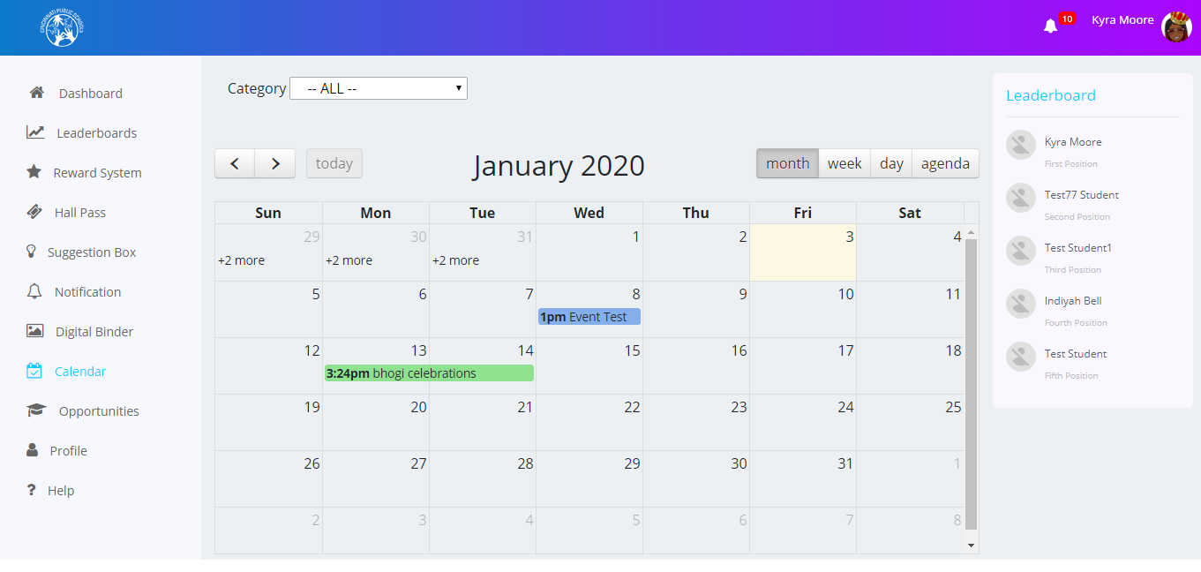

#### Adding calendar event:

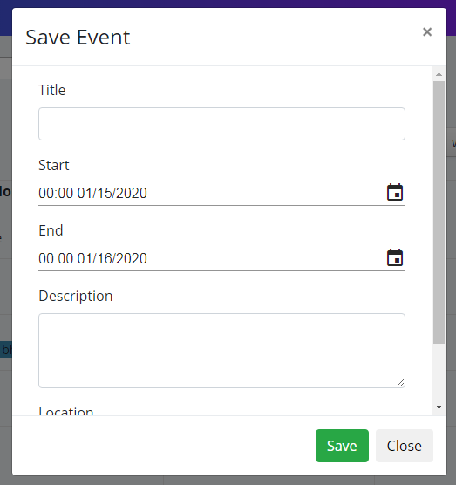

* Specify the Calendar details title and start date, end date, location and click the **Save** button.

You can also view the event details and edit/delete the events.

#### To view the event:

* Click on the event name in the calendar window is displayed.

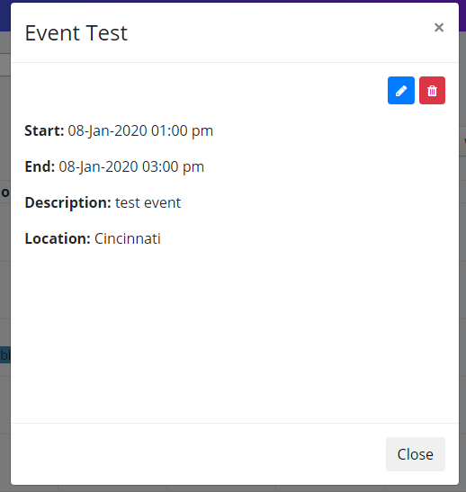

#### Edit Event:

* To Edit an event, click on icon to edit the event. The below window will be displayed.

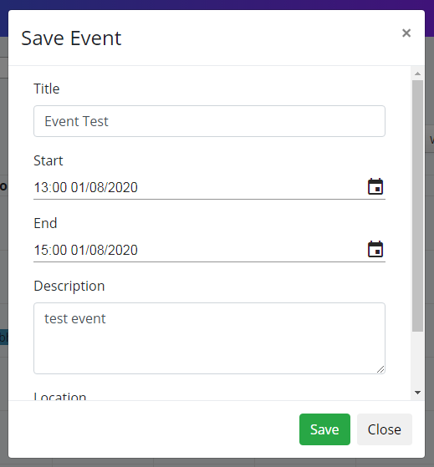

#### Deleting an Event:

* To delete an event, click on icon. Then the event will be deleted.

Adding admin Event to Students calendar:

* Click on the Admin Created event. The below window will be displayed.

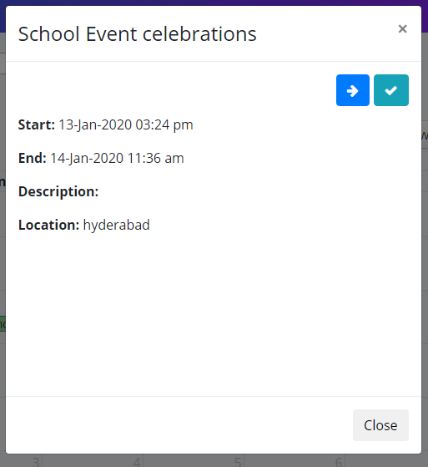

#### Add Event details to Calendar:

* Click on  icon to add the event to the student’s calendar.

#### View the Admin event details:

* Click on  icon to view event details and event tags. The below screen will be displayed.

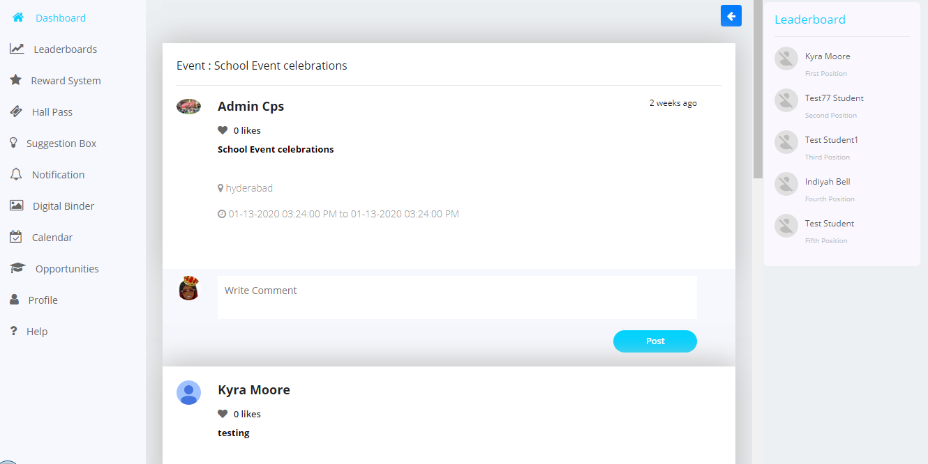

### Opportunities:

The opportunities screen contains the information of the jobs posted by the partner organizations. A student can see the jobs matching to their profile by the stars.

#### All Opportunities:

* All opportunities screen displays the jobs matching to the student

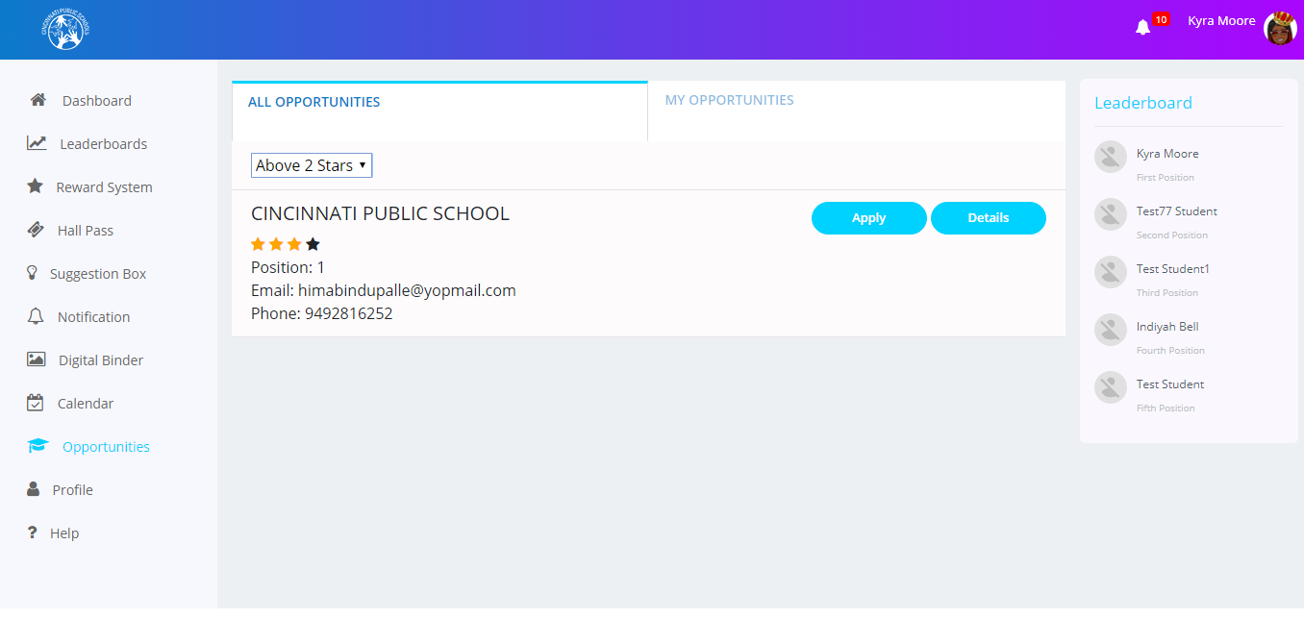

Applying to Job:

* By Clicking on the Apply button, a student can apply to their desired job.

#### My Opportunities:

This screen will display the jobs applied by the students. The students can see the status of their job application - applied, selected or rejected.

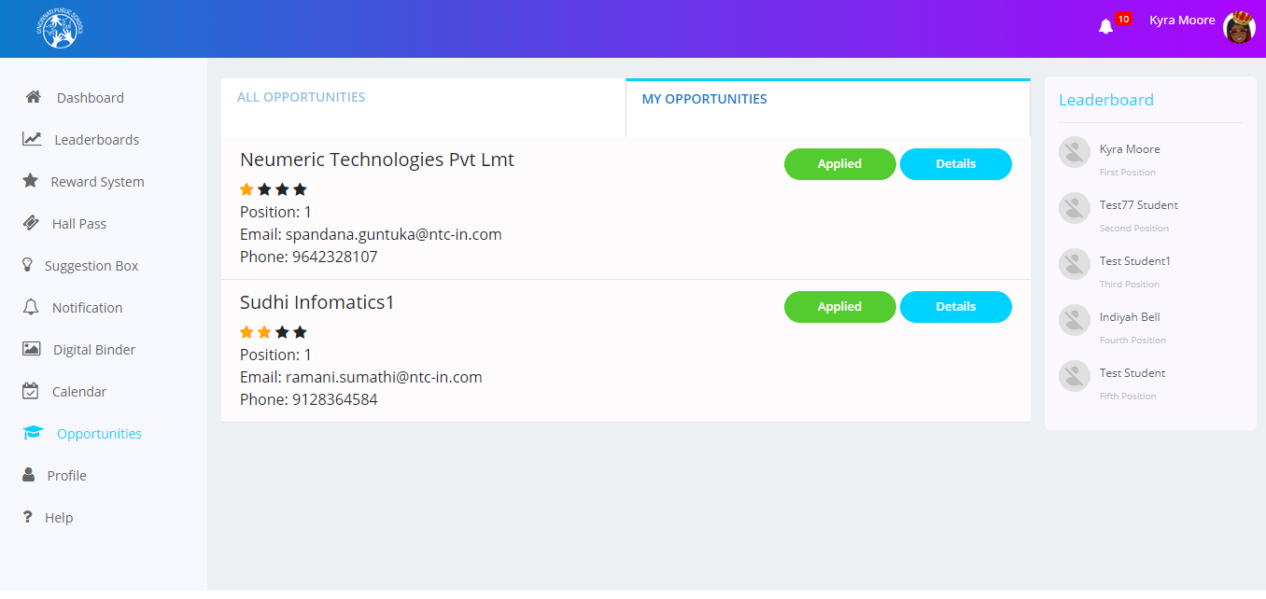

Job Details:

* By clicking on the “Details” Button, the below screen will be displayed.

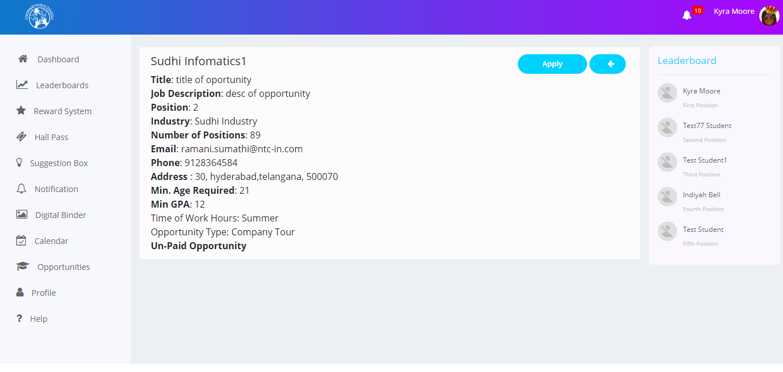

* A student can see all the information about the job opportunity here. From the details screen also, a user can apply for job by clicking on Apply button.

### Profile:

The profile screen contains the information of the users News feed, About, Resume profile, and Opportunities

#### News feed tab:

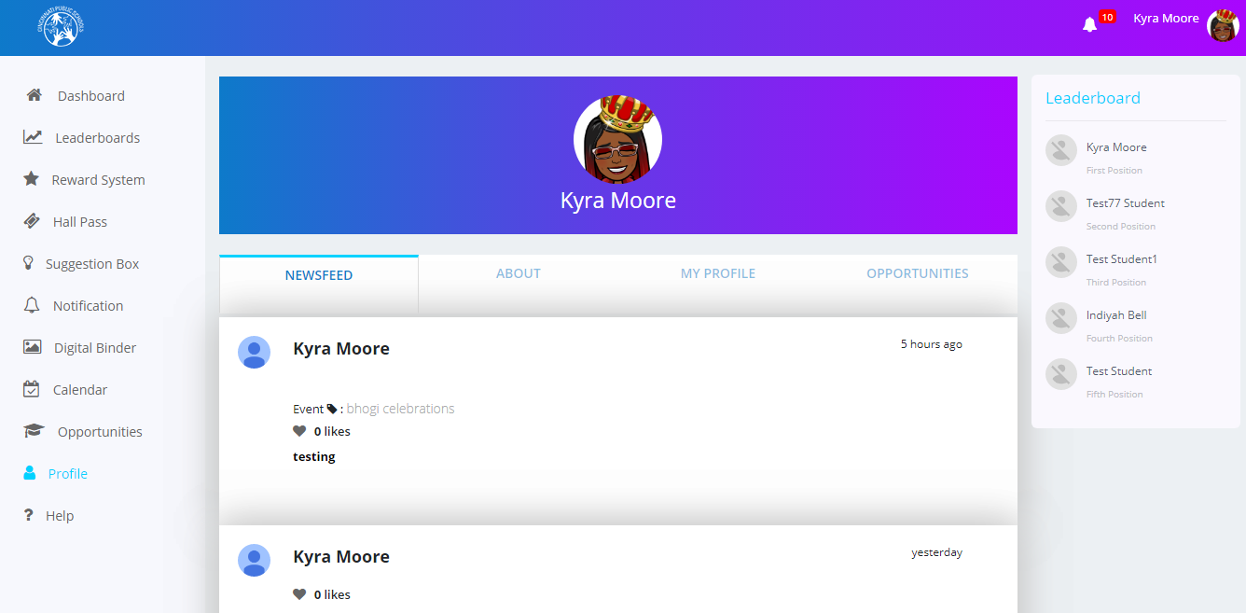

* This tabdisplays the posts of the user

#### About:

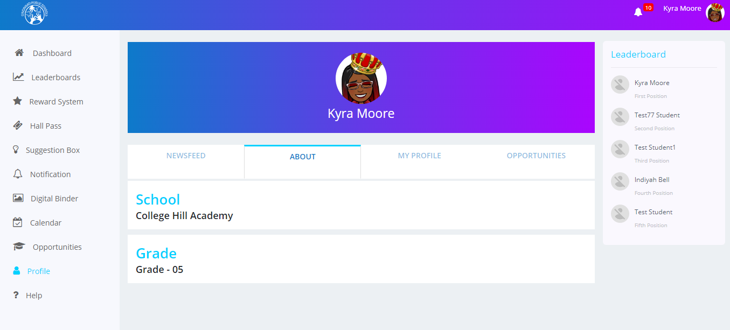

* This tab displays the school and grade information of the user.

#### Profile tab:

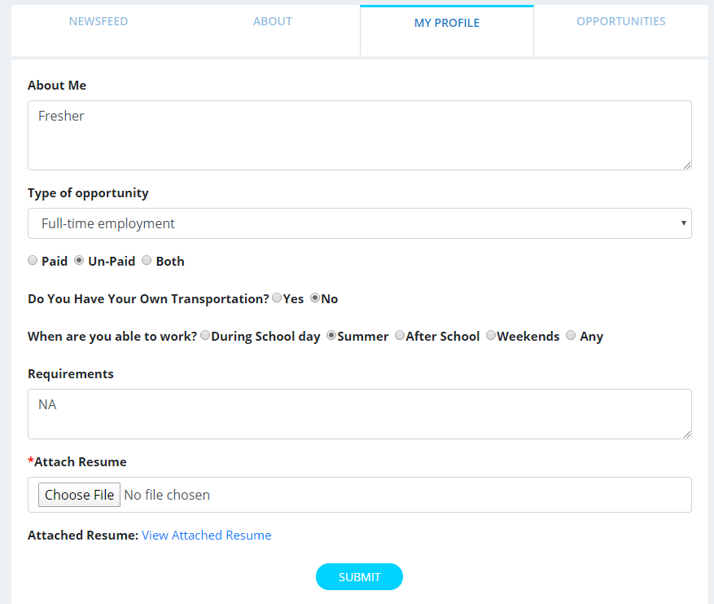

* In this screen, the students can create their profile and upload resume with their information

#### Opportunities tab:

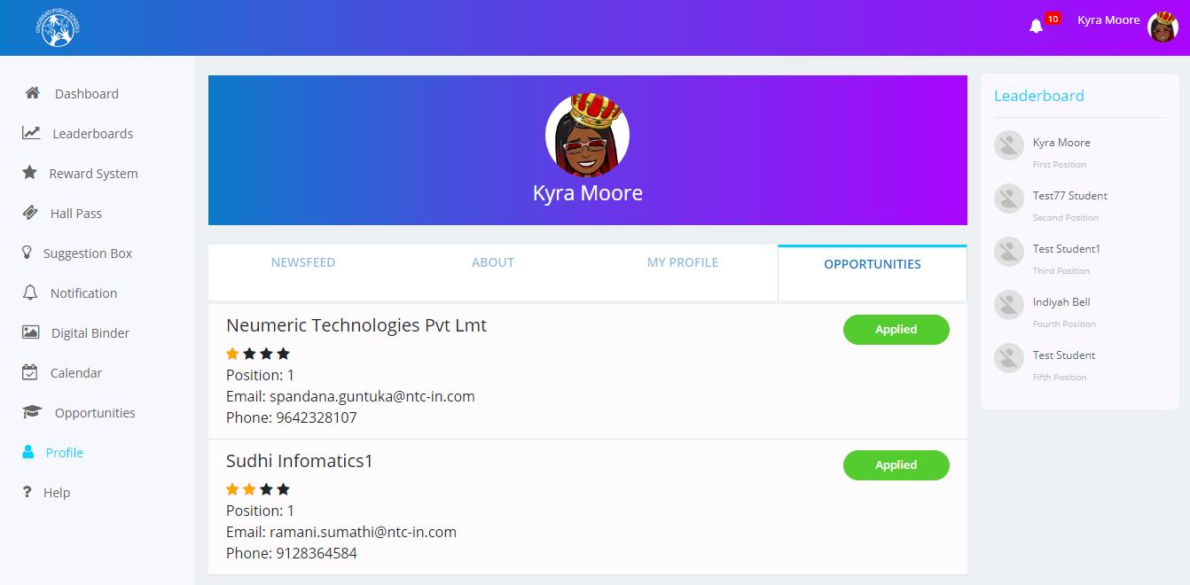

### Help:

The Help screen contains information about the various sections of the application and the instructions to help the user use the application easily.

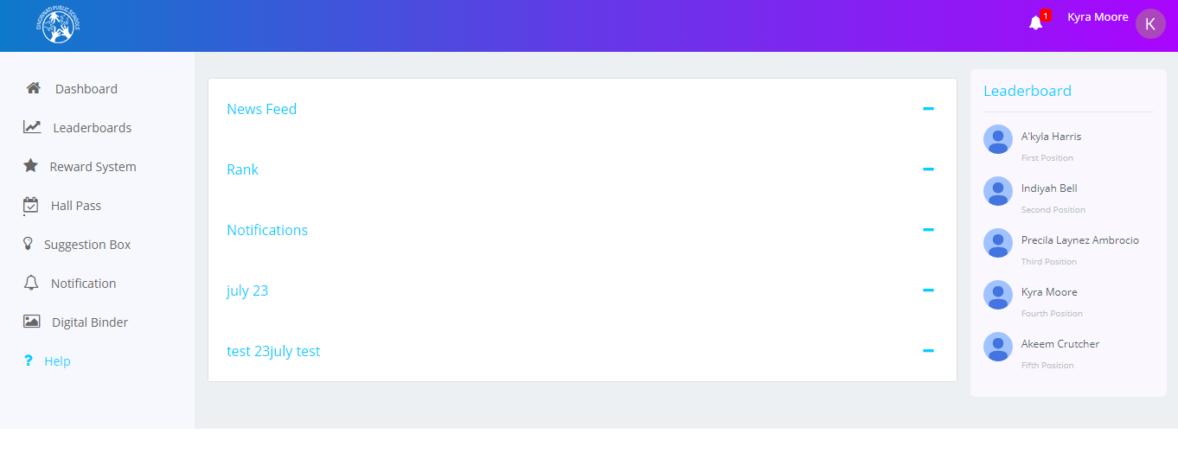

## Teacher Login

### Dashboard:

When you log in as a teacher, you can view the news feeds posted by the students, teachers or admin users. You can post content including text, pictures, videos You can also like posts and comment on the posts .

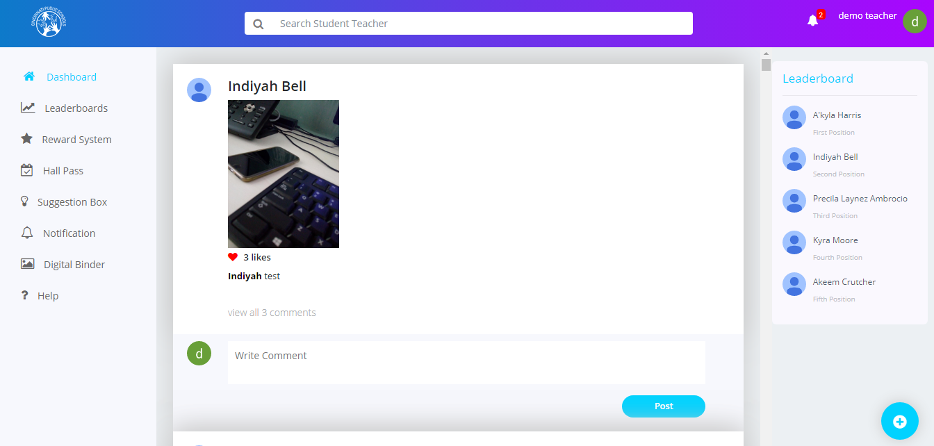

#### Search:

Teachers can search for information on the website based on certain key words. There is a **Search** text box available at the top of the dashboard screen. They can type in their keyword and the search result will be displayed below the **Search** text box based on the keyword typed .

#### Adding News feed

On this screen, teachers can post content including text, pictures videos. The user can also like posts and comment on various posts .

To add a newsfeed:

* Click the + icon at the bottom of the Dashboard screen. The ‘**Create News’** window is displayed.

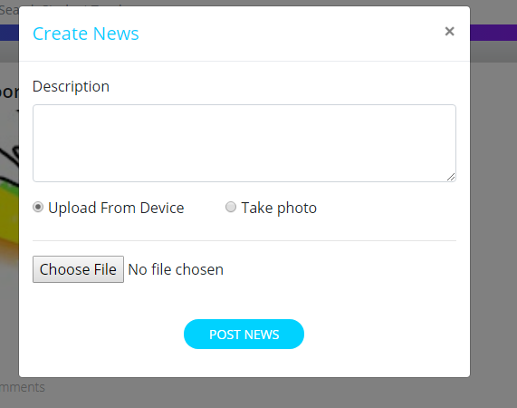

* In this screen, you can upload a file from a device or you can click a picture using the webcam.
* After filling the information, click on the **Post News** button to post the news feed.

#### Editing or Deleting a Newsfeed

Teachers can edit or delete only their newsfeeds posted on their individual dashboards by clicking on the icon.

To edit a newsfeed:

* Click on the icon and click the **Edit News** button. The **‘Edit News Feed’** window is displayed.
* Edit the description and upload a different image or
* Click the **Update News** button to save your changes

**Note:** You need to delete the existing video or image to upload a new one in its place.

To delete a newsfeed:

* Click on the icon and click the **Delete News** button.

### Adding Event to personal calendar:

* Click in the  icon to add the event to calendar



### Commenting on a Newsfeed

Students can comment on newsfeeds in displayed in the Dashboard screen.

To comment on a newsfeed:

* Select the newsfeed you wish to comment on from the Dashboard screen.
* Type your comment in the **Write** text box.
* Click the **Post** button.



**Note:**

* All the comments made by Students need Admin approval.
* You can view all the comments for that news feed by clicking the view all comments link.

### Notifications:

The Notifications screen displays all the updates related to the teachers including likes, comments made on the newsfeeds, notifications when the hall pass is approved. You can click on any notification to access the details of that notification.

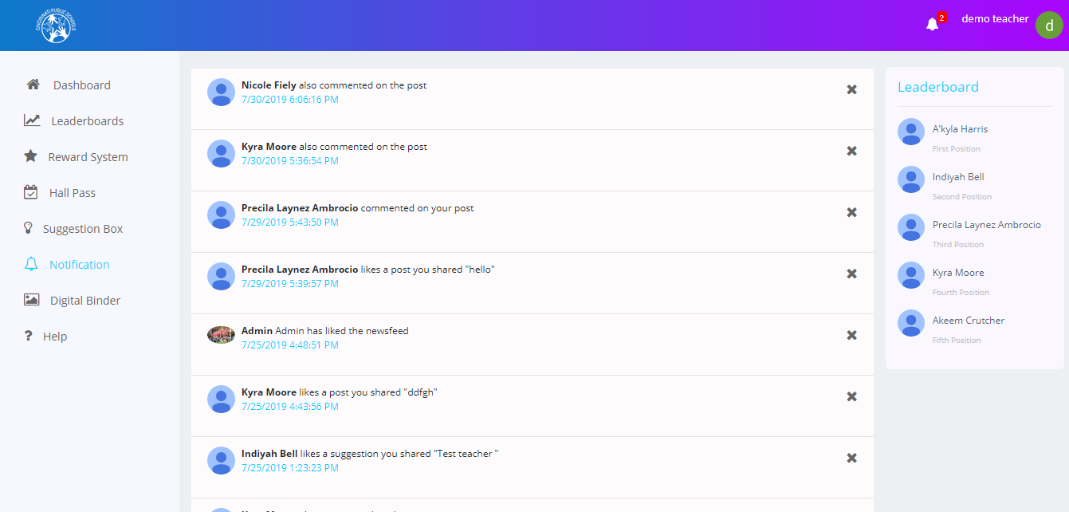

### Leaderboards:

The Leaderboards screen displays the details of the students. Details including rank, points, levels are displayed. You can filter these details by selecting or unselecting the **My School** checkbox.

**Note:** If you select the **My School** checkbox, you can view the details of only those students who belong to your school.

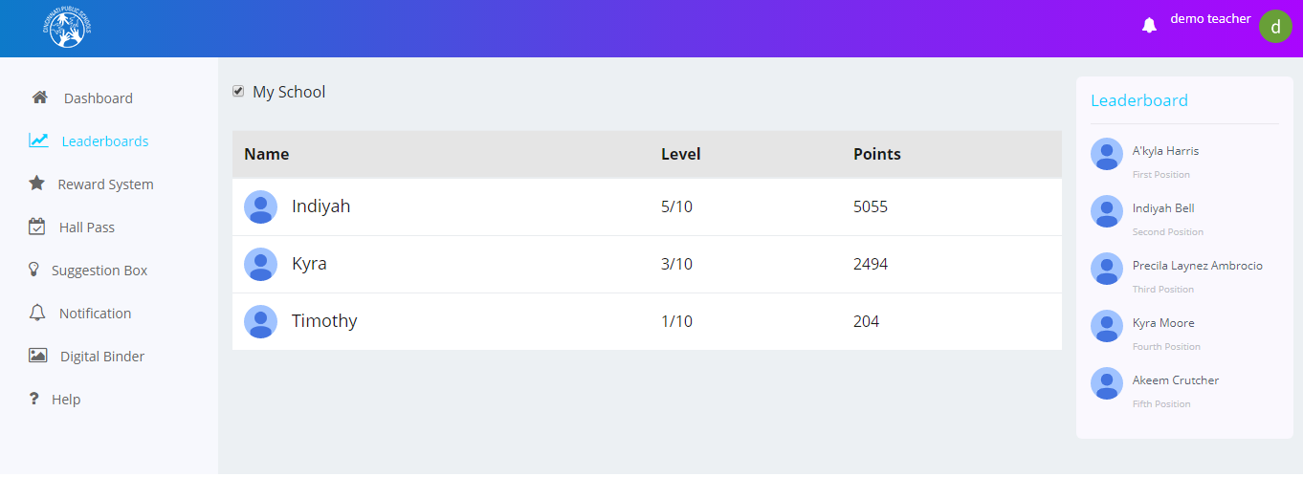If you unselect the checkbox, you can view the details of the students of all the schools.

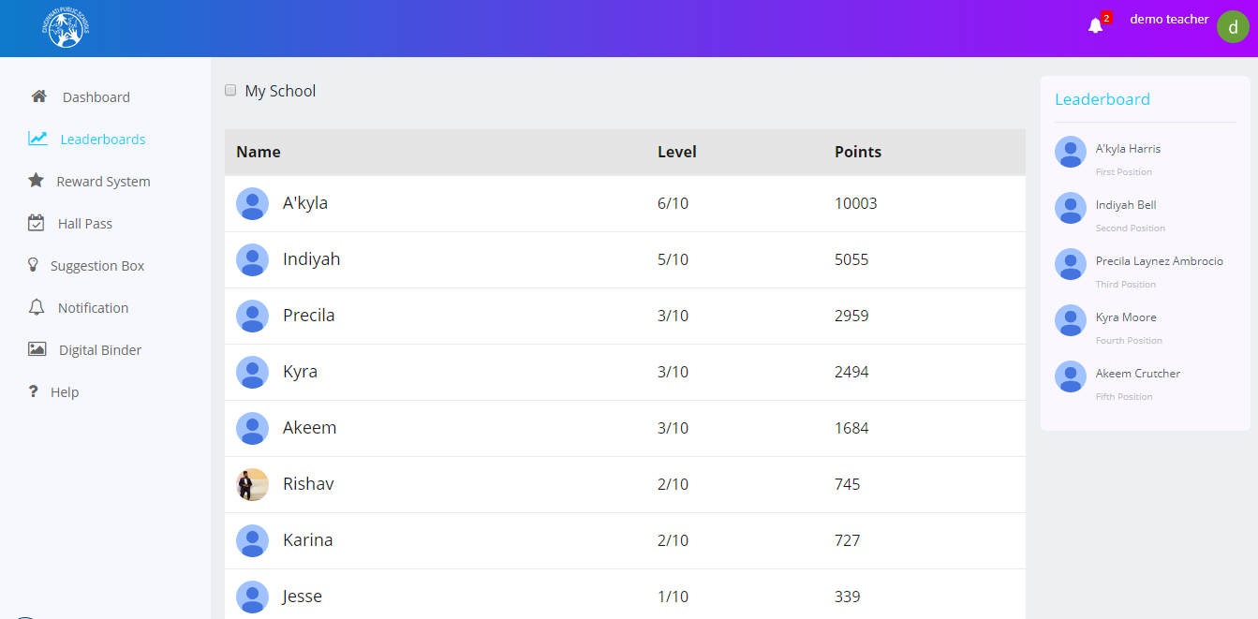

### Rewards System:

On this screen, the teachers can assign reward points to their students.

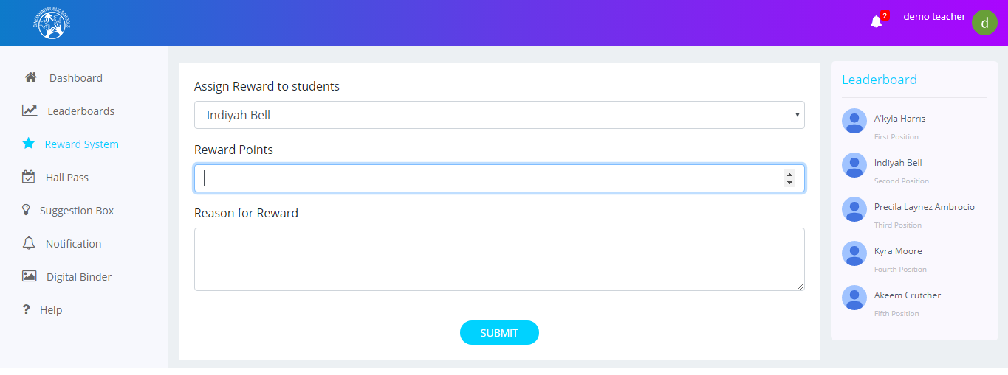

#### Assigning Rewards

To assign rewards to a student:

* Select the student from the **Select a Student** drop-down list
* Enter the number of points and the reason for assigning the rewards in the respective text boxes.
* Click the **Submit** button.

### Hall Passes:

The Hall Passes screen contains three tabs.

The first tab is the **Hall Pass Request** tab which displays all the hall pass requests along with information including description, destination, valid from(validity date), expire on(expiry date) . You can approve or reject a hall pass by clicking on the **Approve** and **Reject** buttons.

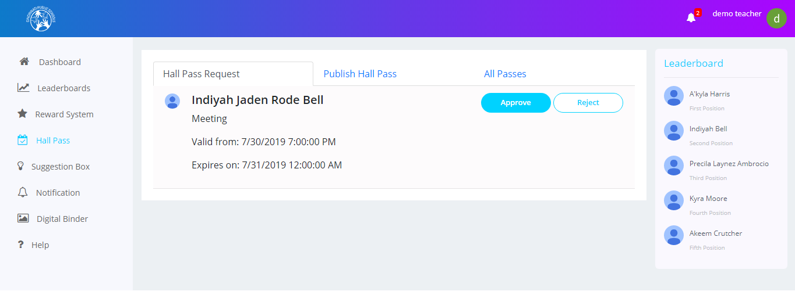

The second tab is the **Publish Hall Pass** tab, whereyou canpublish new hall passes for students. You need to specify information including student name, reason, destination, start date time, and end date time and click the **Submit** button

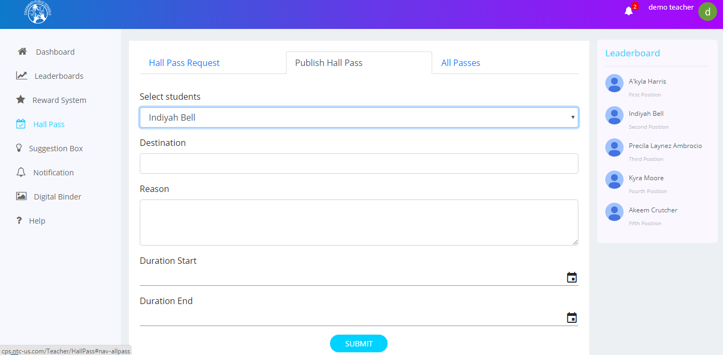

**Note:** You cannot choose a past date range for the hall passes. You need to always choose a future date range.

The third tab is the **All Passes** tabwhich displays all the hall passes that have a status associated with them.

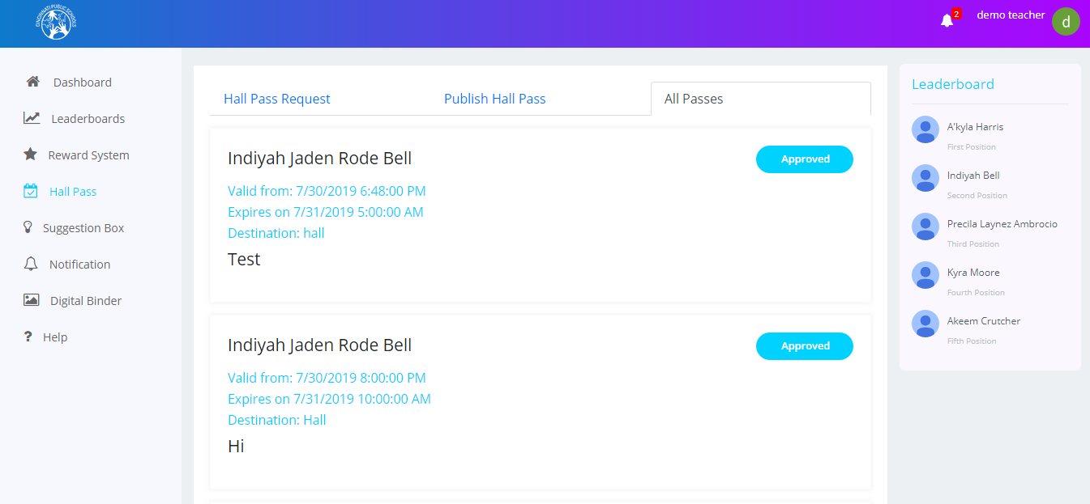

### Suggestion Box:

The ‘**Suggestion Box’** screen for teachers displays the suggestions posted by the students who are logged in to the website. You can like or comment on those suggestions.

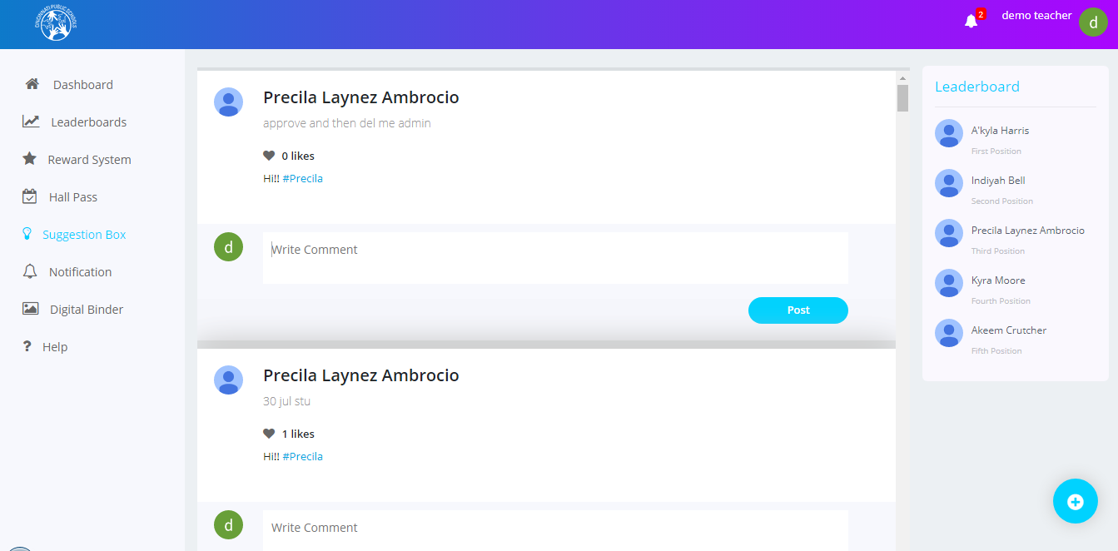

#### Adding a New Suggestion

To add a new suggestion:

* Click the + icon in the ‘**Suggestion Box’** screen.

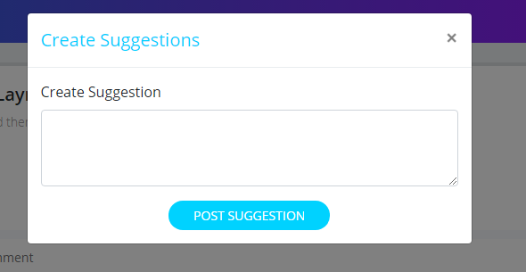

* The Create Suggestion window is displayed. In this window, describe your suggestion and post it by clicking the **Post** **Suggestion** button.

### Digital Binder:

The Digital Binder screen displays all the assignments of those students assigned to you. You can add a new assignment from this screen.

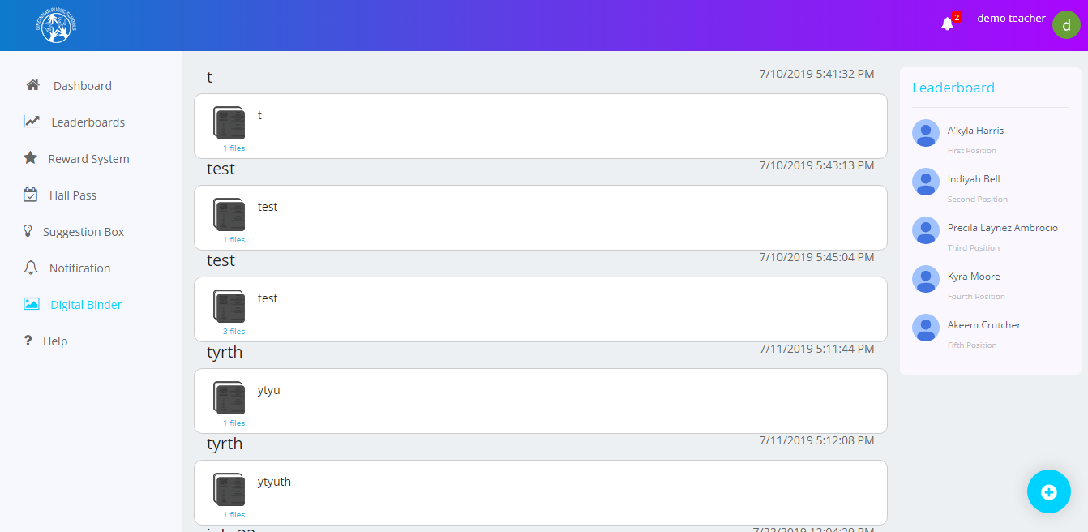

#### Adding a New Assignment:

To add a new assignment:

* Click the **Add** button from the Digital Binder screen.
* The **‘New Assignment’** window is displayed. In this window, specify the assignment name and description, attach media such as pictures or videos and click the **Submit** button.



You can also edit the assignments and view their attachments.

To accomplish this:

* Click the file icon on the Digital Binder screen. The Edit Assignment window is displayed.



You can edit the details of the assignment and view or remove the assignment’s attachment.

* To view the attachment, click the file icon displayed below the description text box. The image is displayed in a new tab.
* Click the **x** delete symbol to delete the attachment.

### Calendar:

Calendar will display the school event added by the admins and the student’s personal calendar events.

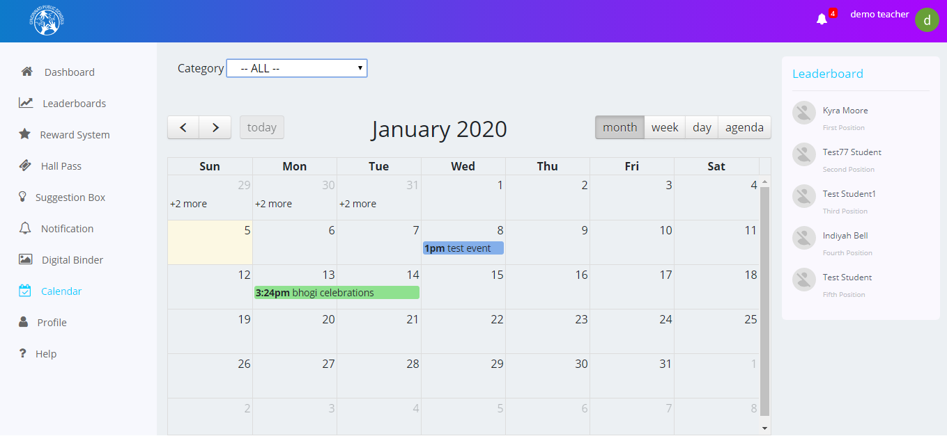

#### Adding calendar event:



* Specify the Calendar details title and start date, end date, location and click the **Save** button.

You can also view the event details and edit ordelete the events.

#### To view the event:

* Click on the event name in the calendar window is displayed.



#### Edit Event:

* To Edit an event, click on theicon to edit the event. The below window will be displayed.



#### Deleting an Event:

* To delete an event, click on the icon. Then the event will be deleted.

Adding admin event to the students calendar:

* Click on **‘Admin Created’** event. Then the below window will be displayed.



#### Add Event details to Calendar:

* Click on the  icon to add the event to students’ calendar.

#### View the Admin event details:

* Click on the  icon to view event details and event tags. The below screen will be displayed.

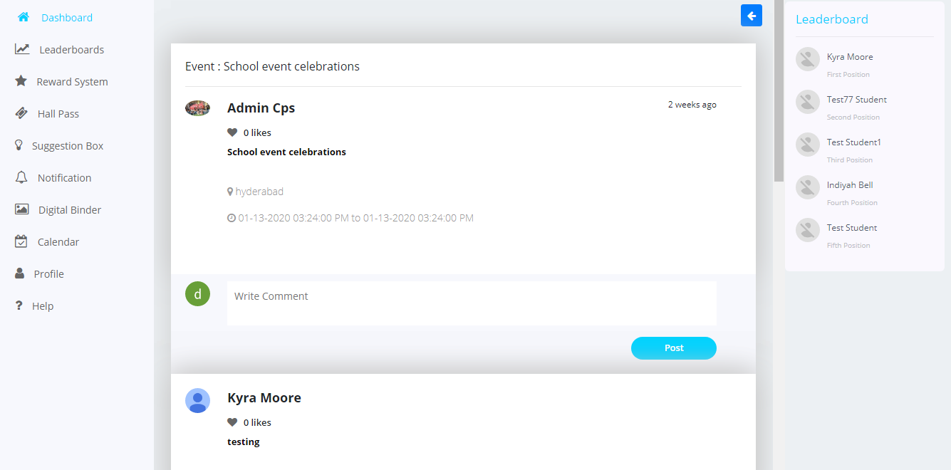

### Profile:

The profile screen contains the information of users including news feed, about, resume profile, and opportunities

#### News feed tab:

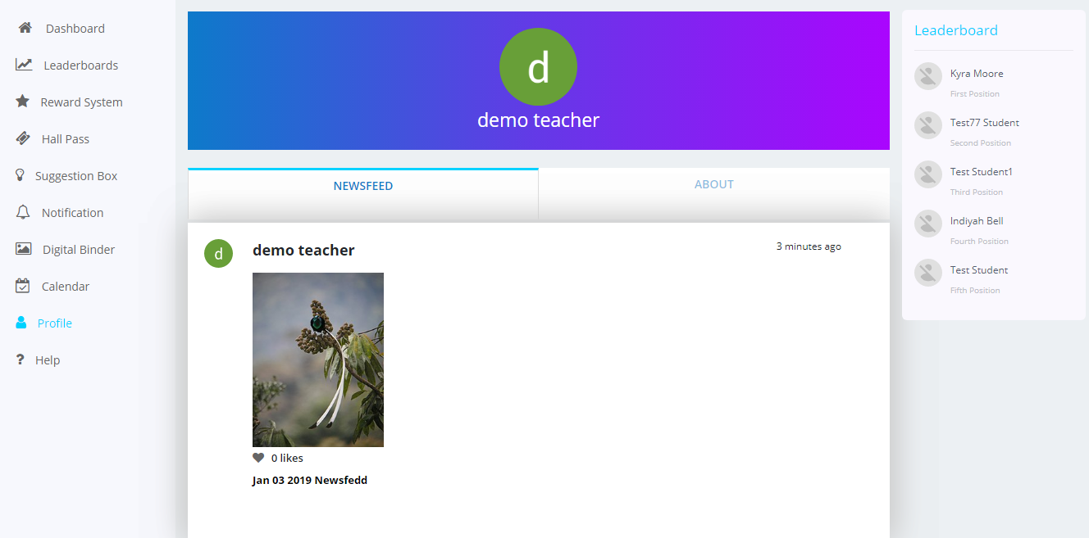

* This tab will display the posts of the user

#### About:

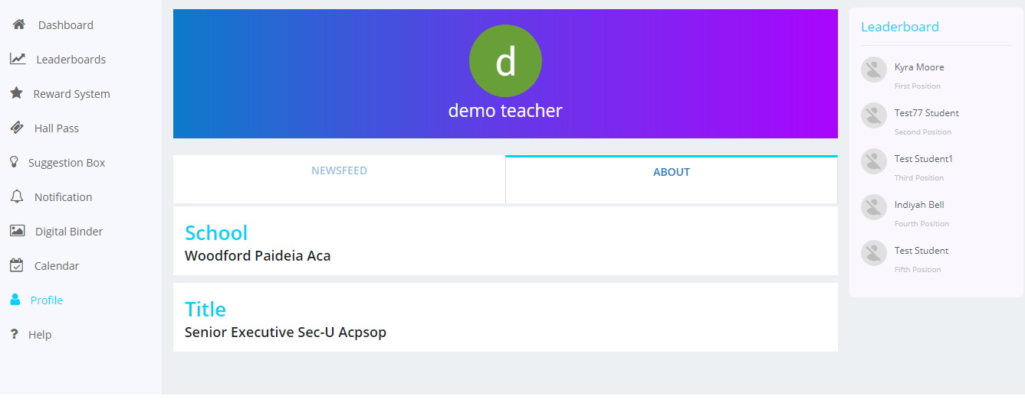

* This tab displays the school and grade information of the user.

### Help:

The **‘Help’** screen contains the information about the different sections of the application and the instructions to help the user to use the application easily.

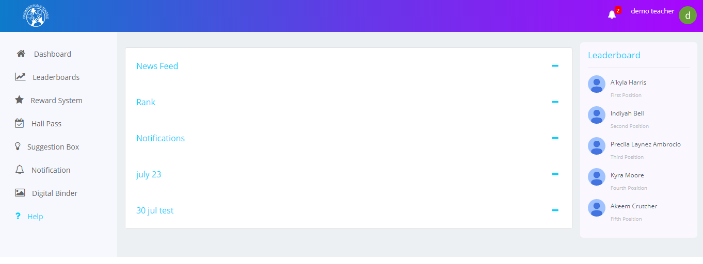

## Logging Out:

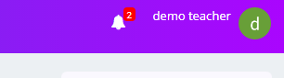

* Click on the user icon to view the logout screen.

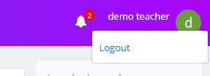

* Click on Logout to exit from the website.